# TE Mini Project - 2A I Care

T.E. mini-project report submitted in partial fulfilment of the requirements of the degree of

**Information Technology**

By

**Gaurang Kumbhar (63) [TEIT-1] Shaina Katoch (54) [TEIT-1] Yamika Machhi (66) [TEIT-1]**

**Satyam Shukla (51) [TEIT-2]**

Under the guidance of

**Mrs. Divya Gajangi**

**(Assistant co-ordinator)**



**Department of Information Technology Atharva College of Engineering, Malad(W)**

**University of Mumbai**

**2022–2023**

i

### CERTIFICATE

This is to certify that the S.E. mini-project entitled **“I-Care”** is a bonafide work of “**Shaina Katoch” (54) [TEIT-1], “Gaurang Kumbhar” (63) [TEIT-1],** and **“Yamika Machhi” (66) [TEIT-1] ,“Satyam Shukla” (51) [TEIT-2]** submitted to University of Mumbai in partial fulfilment of the requirement for the award of the degree of **“Information Technology”** during the academic year 2022–2023.

**Mrs. Divya Gajangi**

Guide

**Prof. Deepali Maste Dr. S.P. Kallurkar**

Head of Department Principal

[INFT]

ii

# T.E. Mini-Project Report Approval

This mini-project synopsis entitled **I-Care** by **Shaina Katoch (54), Gaurang Kumbhar (63), Yamika Machhi (66) , Satyam Shukla (51)** is approved for the degree of **Information Technology** from University **of Mumbai**.

**Examiners**

1.

2.

Date: / /2022 Place: Mumbai

iii

# Declaration

We declare that this written submission represents our ideas in our own words and where others’ ideas or words have been included, we have adequately cited and referenced the original sources. We also declare that we have adhered to all principles of academic honesty and integrity and have not misrepresented or fabricated or falsified any idea/data/fact/source in our submission. We understand that any violation of the above will cause disciplinary action by the Institute and can also evoke penal action from the sources which have thus not been properly cited or from whom proper permission has not been taken when needed.

Signature

Gaurang Kumbhar (63)

Signature Shaina Katoch (54)

Signature Yamika Macchi(66)

Signature Satyam Shukla (51)

Date: / /2022

iv

### Abstract

In this project, a website for medical healthcare system was designing and developing. It consists of two major sides: client- server side (front end side and back- end side). The client side is everything involved with what the user sees, it has been designed a web using HTML, CSS and JavaScript languages. The server-side is mainly how the site doing modifications and updates which indicates to the entire user can't see everything in the browser such as servers and databases. The web has been implemented SQL Server languages used for the database part and it make simple ease of use for patients to their health registrations. Consequently, it has simple and straight accessibility through a group of physicians for patient records. The article interested with auspices to the patient appointments combination, billing, timetable, physical, date, and information of medication in single overall system. The results of website designed provide accessibility with easy manner of pertinent information to the management organizations for instance the Medicaid and Medicare. Furthermore, the website reduces the mistake in healthcare, and reduce the cost of delivery of healthcare. Consequently, the website prepared for utilize by nurses, physician, pharmacists and another healthcare professionals, and by patients and monitor patients using medical devices.

E-health, often known as e-healthcare, is the use of modern digital electronic and communication technology like computers, mobile devices, and the internet to make medical treatment more accessible without any direct contact. Nowadays smart e- healthcare systems make use of a number of technologies to provide a wide range of medical services, for example, online appointments, remote appointments over

the internet, prescribing e-prescriptions, seeking healthcare advice and information via the internet, etc. Although e-health is increasingly being promoted in developed counties, in developing countries like Bangladesh it’s still at an early stage. But the deployment of smart e-healthcare makes perfect sense for developing countries since the proper integration of such systems can ensure better efficiency especially in the rural regions where medical services are limited due to extreme scarcity of qualified medical professionals

**Keywords—Healthcare, Client-Side, Service, Server-Side, SQL Server, web applications.**

v.

### Table of Contents

|  |  |  |
| --- | --- | --- |
| **Chapter** | **Topic** | **Page No.** |
|  | **Abstract** | **v** |
|  | **List of Figures** | **vii** |
|  | **List of Table** | **viii** |
| **Chapter 1** | **Introduction** | **1** |
|  | 1.1 Motivation | 3 |
|  | 1.2 Problem Statement | 4 |
|  | 1.3 Objectives | 5 |
|  | 1.4 Scope | 6 |
| **Chapter 2** | **Review of Literature** | **7** |
| **Chapter 3** | **Proposed System** | 9 |
|  | 4.1 Proposed System | 10 |
|  | 4.1.1 Block diagram | 11 |
|  | 4.2 Implementation | 12 |
|  | 4.2.1 Algorithm/Flowchart | 13 |

|  |  |  |
| --- | --- | --- |
|  | 4.2.2 Dataset | 14 |
| **Chapter 4** | **Results Analysis (**Screenshots of the output with description ) | 20 |
| **Chapter 5** | **Conclusion** | 21 |
| **Chapter 6** | **Future Scope** | 22 |
|  | **References** | 23 |

vi

### List of Figures

|  |  |  |
| --- | --- | --- |
| **Figure No.** | **Figure Name** | **Page No.** |
| 1 | DFD : level 1 | 17 |
| 2 | Block Diagram | 17 |
| 3 | Business Model | 18 |
| 4 | Flow Chart | 19 |
| 5 | Home Page | 21 |
| 6 | SignUp Page | 22 |
| 7 | E-Pharmacy Page | 22 |
| 8 | Dr Consultation login | 23 |
| 9 | Dr Consultation | 23 |
| 10 | Health Tracker(Body Shape Calculator) | 24 |
| 11 | Health Tracker(Ideal Fat Calculator) | 24 |
| 12 | Health Tracker(Fat Calculator) | 25 |
| 13 | Health Tracker(BMR Calculator) | 25 |

vii

### List of Tables

|  |  |  |
| --- | --- | --- |
| **Table No.** | **Table Name** | **Page No.** |
| 3.1 | Literature survey | 11 |
|  |  |  |
|  |  |  |
|  |  |  |
|  |  |  |
|  |  |  |
|  |  |  |
|  |  |  |

viii

### Chapter 1

### Introduction

Many people and organizations today have a new or renewed interest in project management. In the past, project management primarily focused on providing schedule and resource data to top management in just a few industries, such as the military and construction industries. Today’s project management involves much more, and people in every industry and every country manage projects. New technologies have become a significant factor in many businesses, and the use of interdisciplinary and global work teams has radically changed the work environment

The main aim of this project is to create a new Digital Health care ecosystem. E-pharmacies integrated services bundling teleconsultation, diagnostics and medicine deliveries. To provide people with the diagnoses of the disease, that would require to input the basic symptoms they are facing and would inform them about the disease they may be suffering from along with the probability of other diseases. Clinical task, or “to-do” lists.

With the use of technology and access to an inventory of multiple stores at a time, E-Pharmacies can aggregate supplies, making otherwise hard- to-find medicines available to consumers across the country. This will significantly help the old and sick patients who are not in a condition to find a pharmacy and the village population where there is limited presence of retail pharmacy. Therefore, the project aims to connect and serve as an intermediary between hospital Pharmacies and patients through a platform that helps in appointments with the doctor, order of medicines with the click of a button, and simultaneously maintain the records of patients and ordered medicines.

#### Motivation

The healthcare industry in the country, which comprises hospital and allied sectors, is projected to grow 23 per cent per annum. According to McKinsey & Co. a leading industrial and management consulting organization, the Indian healthcare sector, including pharmaceutical, diagnostics and hospital services, is expected to more than double its revenues to Rs 2000 billion by 2010. Expenditure on healthcare services, including diagnostics, hospital occupancy and outpatient consulting, the largest component of this spend is expected to grow more than 125% to Rs 1560 billion by 2012 from Rs 690 billion now**.**

Nowadays smart e-healthcare systems make use of a number of technologies to provide a wide range of medical services, for example, online appointments, remote appointments over the internet, prescribing e-prescriptions, seeking healthcare advice and information via the internet, etc. Although e-health is increasingly being promoted in developed counties, in developing countries. But the deployment of smart e-healthcare makes perfect sense for developing countries since the proper integration of such systems can ensure better efficiency especially in the rural regions where medical services are limited due to extreme scarcity of qualified medical professionals.

First, online healthcare enables real-time online consultations. These clinical consultations through the Internet can assist patients in communicating with one or more doctors. Conducting clinical consultations online can benefit both patients and doctors, such as by reducing the time spent by the doctors on patients and making the interactions easier.

An online healthcare service can promote the managing of an individual’s health records remotely. In a traditional healthcare service, health records are stored in the hospitals’ information systems, or with the patients on printed records. These records include a patient’s previous health status, diagnosis and treatments.

#### Problem Statement:

In today’s age, mankind is being squeezed out due to anxiety, work patterns, etc. People fail to provide the required concern towards their health and other physical changes related to their body.

In the existing health care system, there is a high chance of misinterpretation of data as well as occurrence of errors. Moreover, it is cumbersome and time consuming. With the increase in volume of patients in the health care institutes, traditional method of management has gone out of phase. As a result of this, an advanced Health Care Management System has been the demand of time.

This project would help people overcome this situation by keeping a track of their daily health count, diet, past ailments, doorstep medicine delivery. Moreover, providing a perfect digital health care ecosystem to overcome their issues. This Health Care system will be like in an online Healthcare Management service provider with easy-to-use customizable options. The application is accessible from anywhere for all employees or staff of the hospital in private or at desktops or tablets etc. it will basically lessen the manual work and improves the quality of maintaining records and other information related to doctors or patients or billing etc. It reduces time frame in adding any info related to hospital and thereby reduce the complexity too.

The main intention of introducing this system is to reduce the manual work at Health center counters. Quicker processing of receipt would mean better service to the patients . It would also help in the complexity of maintaining the records manually and thus less time is wasted on rework. The system is used to enter the patient details and to enter the details about the health center and the details about the in-patient and out-patient in detail and about the reports of the patients .

#### Objectives:

To keep the software user-friendly.

To profound data for health reporting and health system planning

To developing new markets by means of new eHealth applications and medical services, thereby strengthening the health industry

To increased effectiveness of patient care, thereby cost saving

This project may play vital role in saving the patient life at emergency time since “Time is life”

user can store information about the Patients that come to the hospital.

Information about Patients is done by just writing the Patients name, age and gender.

Generating bills. This system also help user in generating bills.

Bills are generated by recording price for each facility provided to Patient on a separate sheet and at last they all are summed up.

This system also store information related to diagnosis given to Patients.

Diagnosis information of patients is generally recorded on a document, which contains Patient information.

This system also store information of the Immunization provided to children/patients.

Keeping information about various diseases and medicines available to cure them.

Information about various diseases is not kept as any document. Doctors themselves do this job by remembering various medicines**.**

### Scope:

The business goal for the application is to provide the medicines to the people in the most cozy manner.

The proposed system aims to build an environment where various patients via their home can consult doctors, send their images, chat with doctors, tell them their issues and discuss remedies. Provide Searching and reading diet plan, reading daily health tips.

Effective and timely communication between patients, physicias , nurses, pharmacists, and other healthcare professionals is vital to good healthcare. Current communication mechanisms, based largely on paper records and prescriptions, are old-

fashioned, inefficient, and unreliable .When multiple healthcare professionals and facilities are involved in providing healthcare fo r a patient, the healthcare services provided aren’t often coordinated. Typically, a physician writes a prescription on paper and gives it to the patient. The patient carries the prescription to the pharmacy ,waits in line to hand the prescription to the pharmacist, and waits for

the pharmacist to fill the prescription. The pharmacist might be u

nable to read the physician’s handwriting; the patient could modif y or forge the prescription; or the physician might be unaware of medications prescribed by other physicians. These and other problems indicate the need to improve the quality of

healthcare .A distributed electronic healthcare system

based on the service-oriented architecture (SOA) can address some of these issues and problems .We developed a distributed e- healthcare system for use by physicians ,nurses, pharmacists, and other professionals, as well as by patients and medical devices used to monitor patients.

**Chapter 2**

**Review of Literature**

This section summarizes the research that has been conducted to assess the importance and efficacy of health information technology.

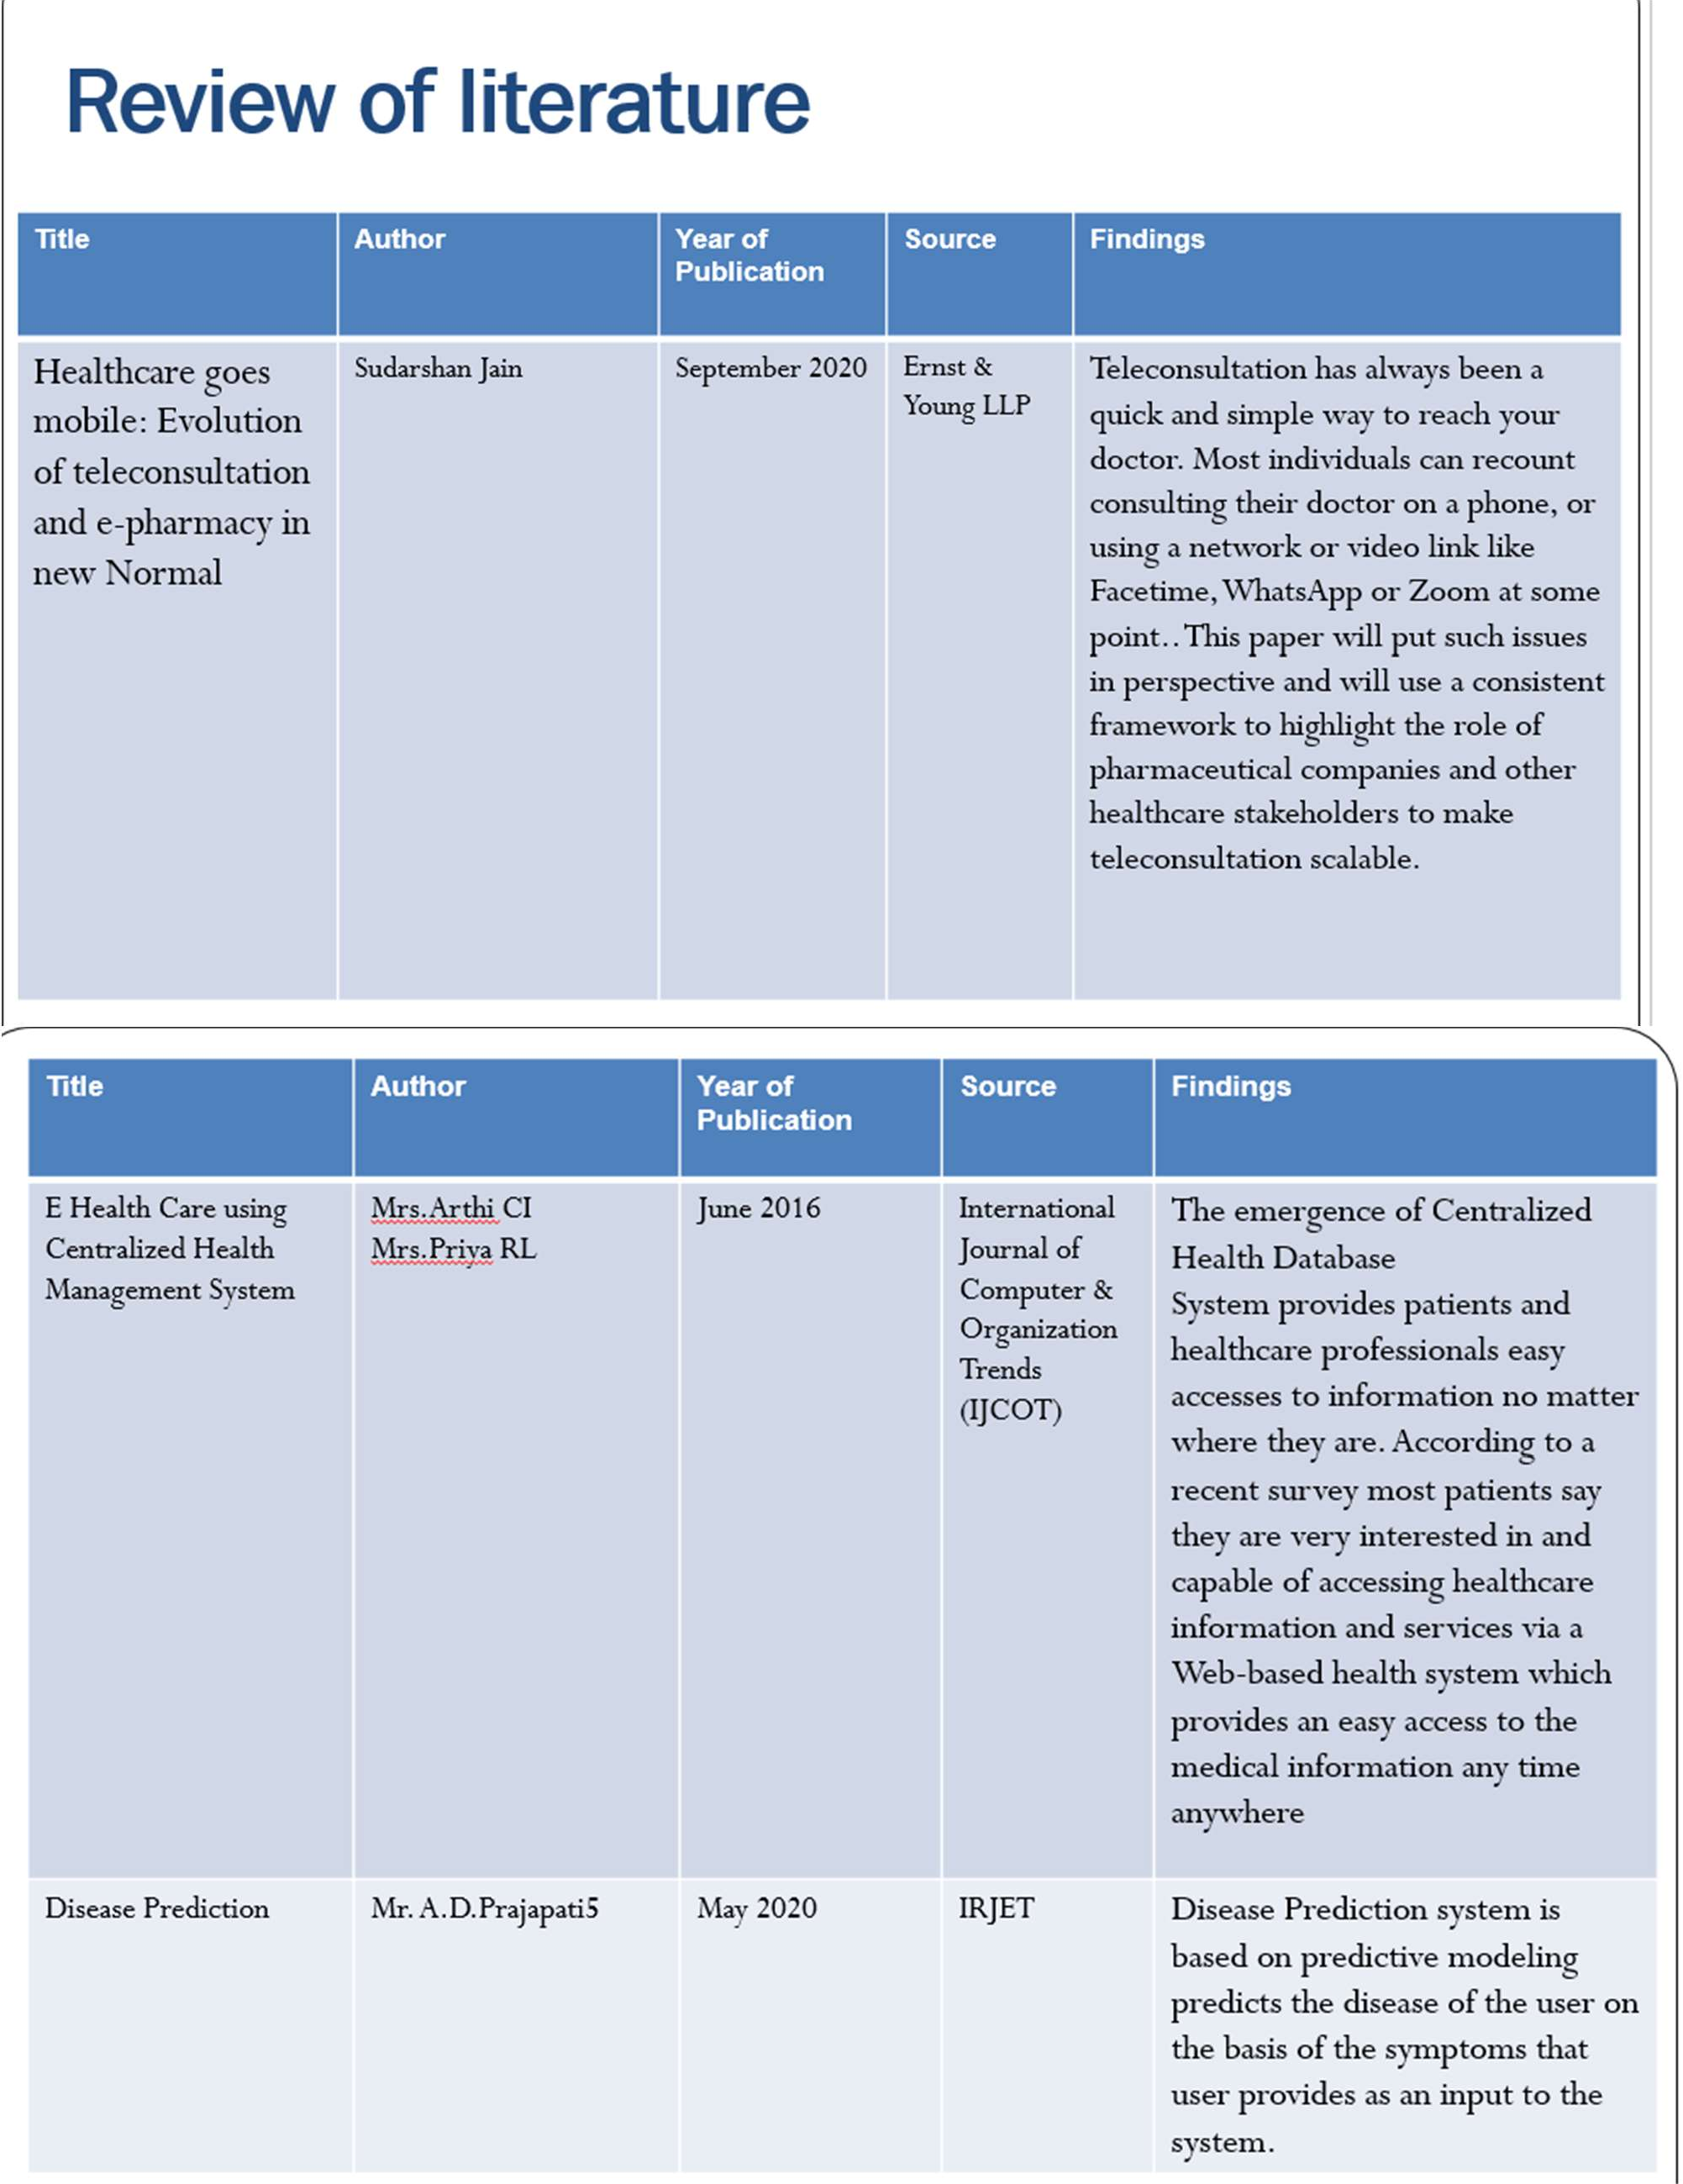

Table : 3.1 Literature survey

**Chapter 3**

**Proposed System**

Our proposed system consists of four major parts or entities or modules such as doctors, patients, admin (system), medicines, reports and blood donation module. But first we must present the requirement analysis that defines the software and hardware requirements of the system to be implemented.

The Healthcare Management System is a web-based application system that an administrator uses as an alternative means of keeping the doctors record, patient’s medical record and patient’s appointment with the doctor. The characteristics are as follows.

1. The administrator records the applicant with their first and last name, matriculation

number, department etc. the matric number along with a login password will be used by the registered user to login.

1. An applicant is permitted to log in with his/her username and password produced at the stage of registering.
2. To view a specific patient’s information, the administrator is responsible to carry out such actions.

The new system is to control the information of patients. Room availability, staff and operating room schedules and patient invoices. These services are to be provided in an efficient, cost effective manner, with the goal of reducing the time and resources currently required for such tasks.

This health information system has two modules namely, Admin and Users. Admin can view the main keyword from the question asked by users, can manage doctor by adding new doctor, updating doctors live information and deleting non-existing doctors. Admin can also delete, update and add new diseases information and cure remedies. Users can ask question regarding a particular disease and get the proper information related to the disease, cure remedies and specialist doctors list from desired or nearby location.

**Data Flow Diagram**

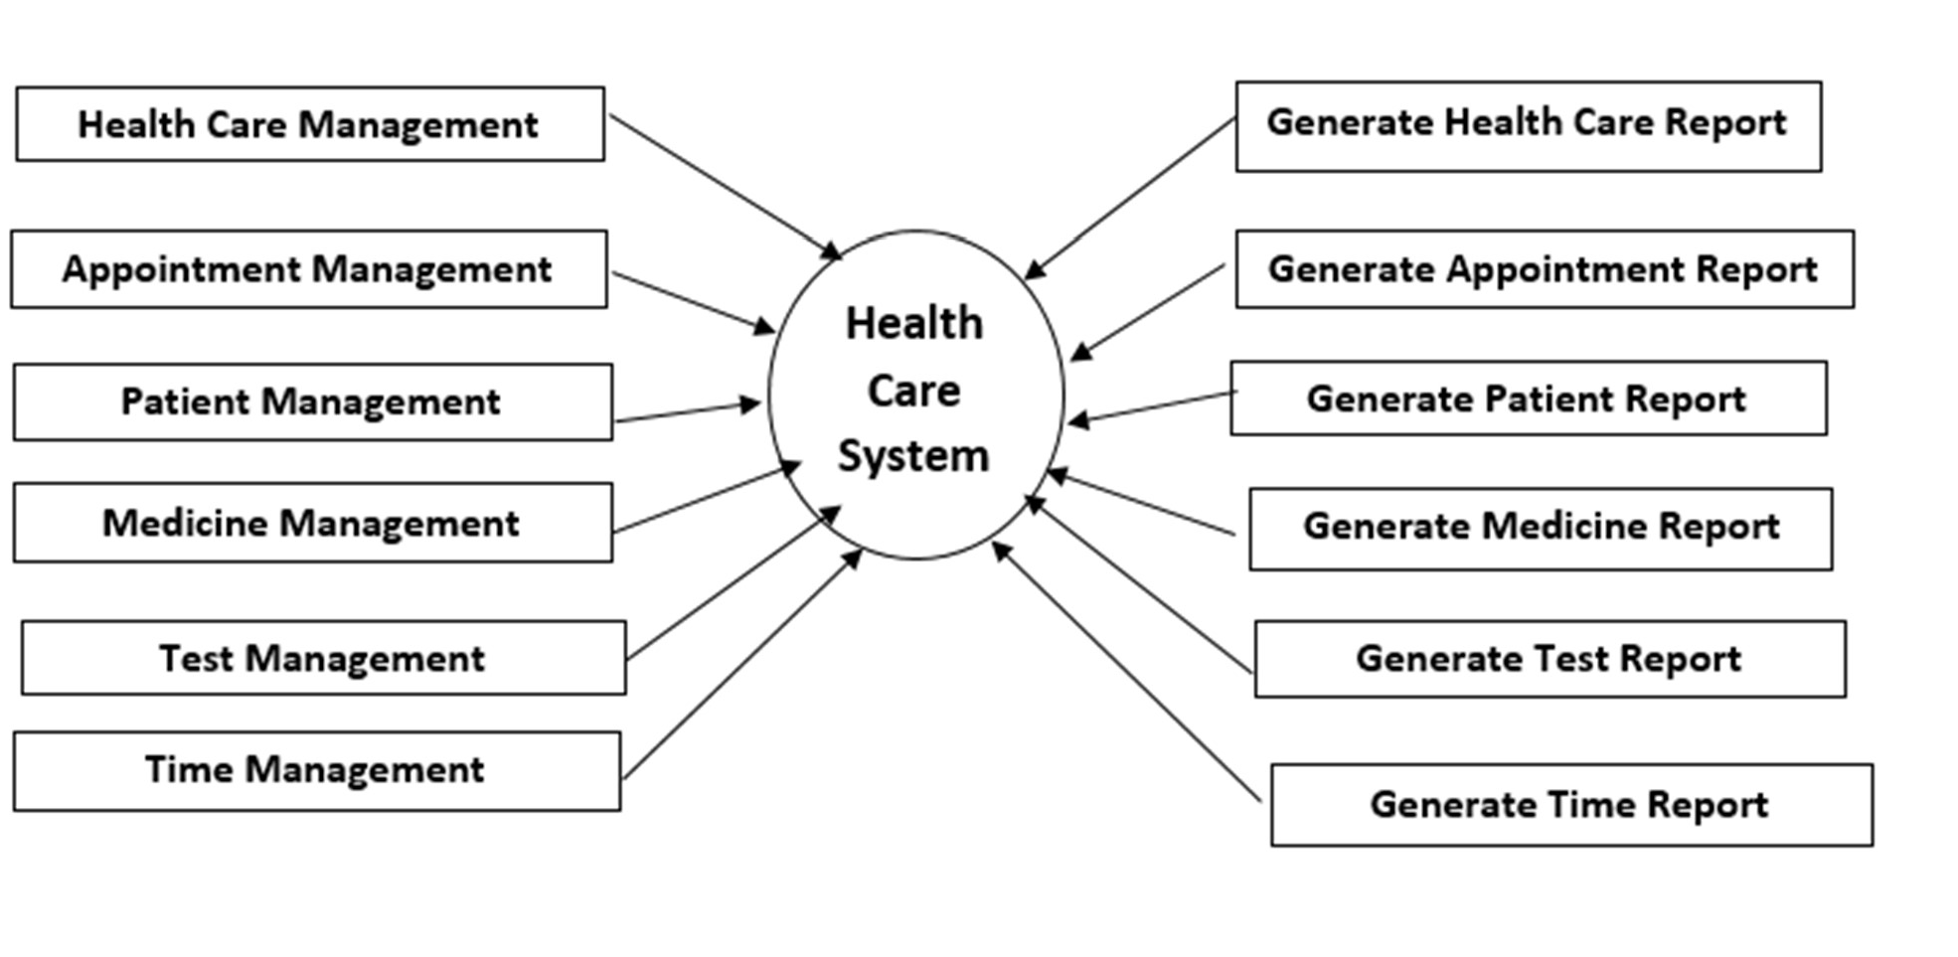

**Fig No 1 : Data Flow Diagram**

**Block Diagram**

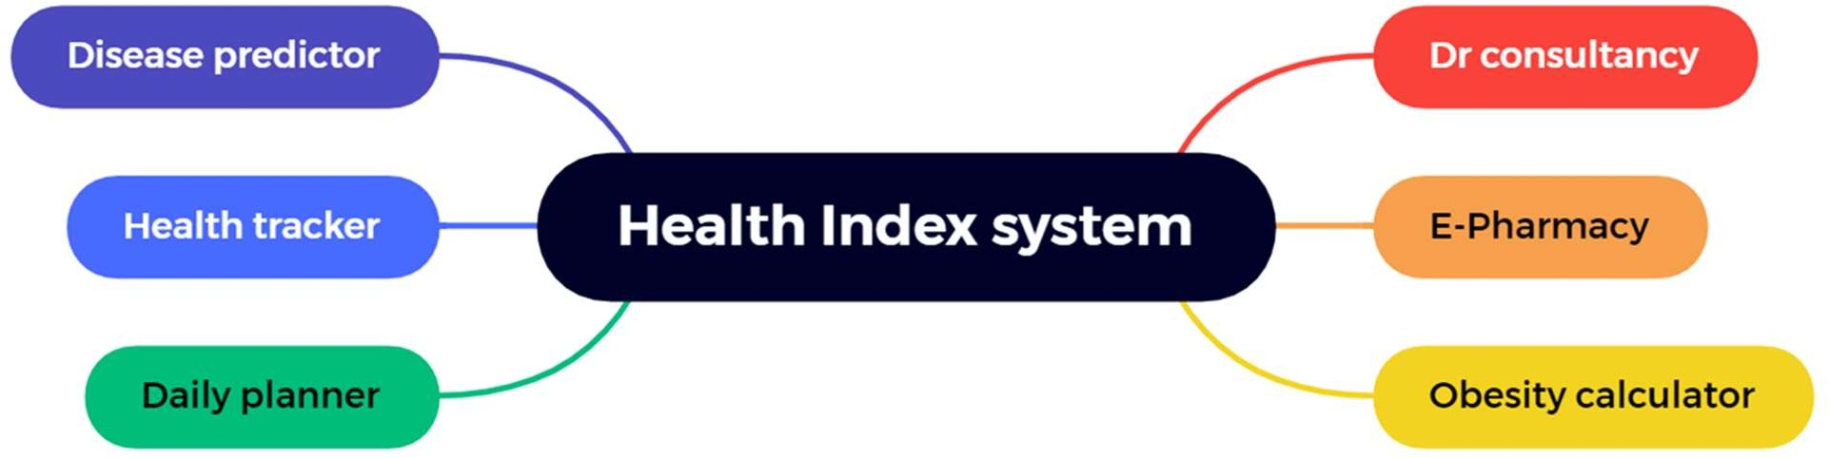

**Fig No 2 : Block Diagram**

**Business Model**

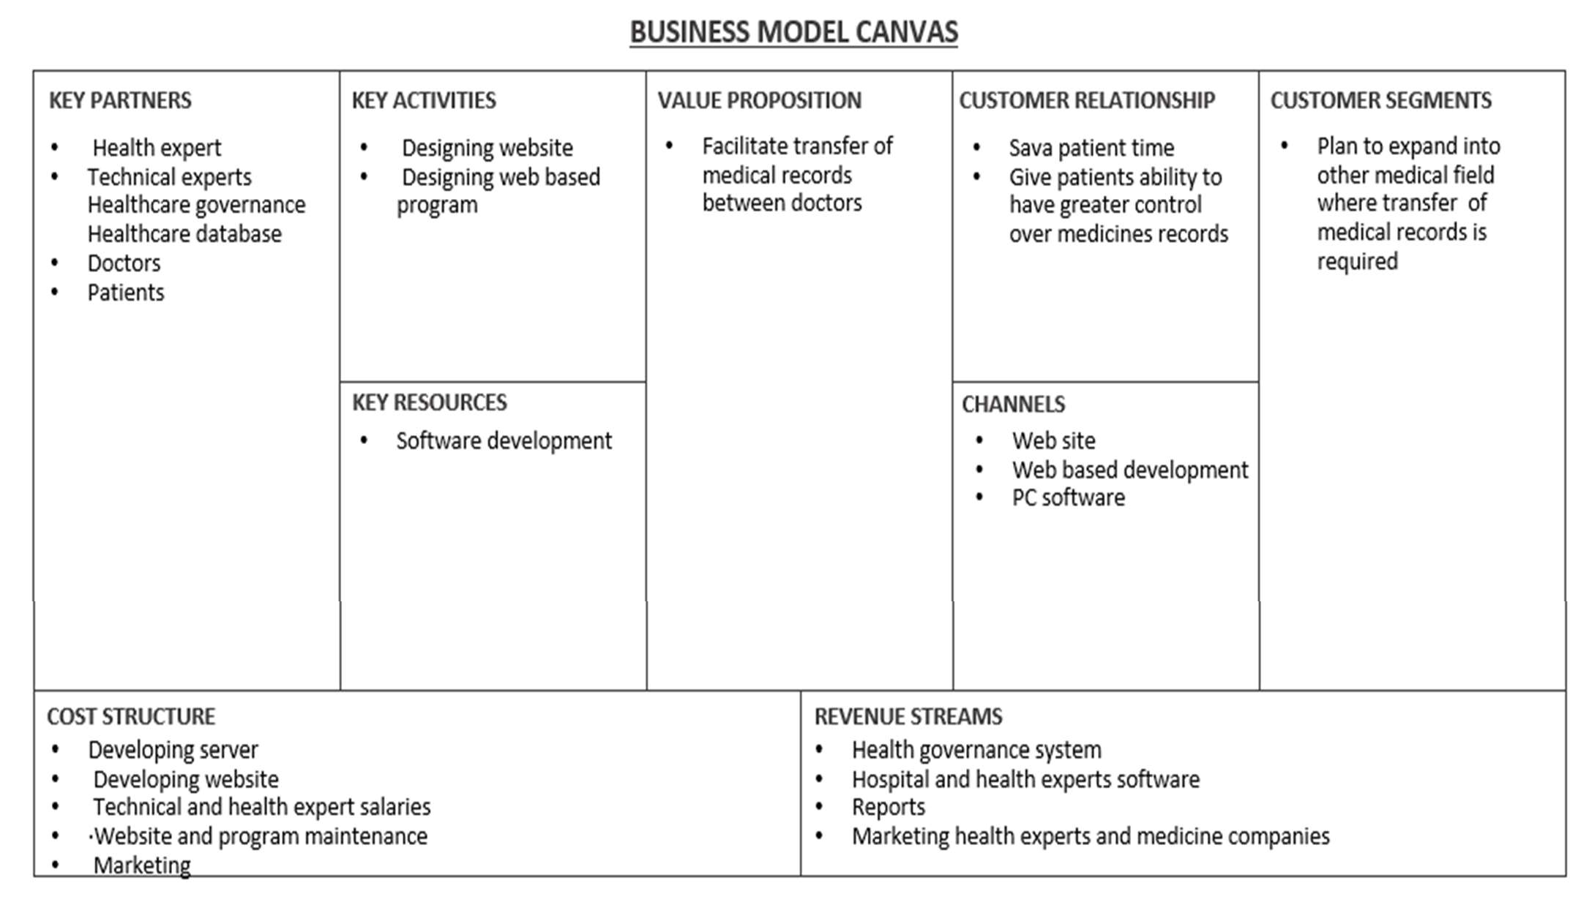

Fig No 3 : Business model

The business model describes the resources, processes, and cost assumptions that an organization makes that will lead to the delivery of a unique value proposition to a customer. As health care organizations are beginning to transform their structure in preparation for a value-based delivery system, understanding business model theory can help in the redesign process.

Through in-depth interviews, we collect information on medical processes, business processes, social impact, and organizational impact according to the Battacharyya et al. framework. We then conducted qualitative analysis to identify common patterns emerging within these four categories.

## Flowchart



**User Login**

**Dr Consultation**

**E Pharmacy**

**Medical data**

**storage**

**Prescribed medicine**

**Health tracker**

**User Logout**

**Patient Care**

**Login Page**

**Signup page**

**Fig no 4 : Flow Chart**

### Dataset

A database is an aggregation and recuperation of intellectuals’ related data. Database testing performs information realness, information uprightness testing, execution check related to database and testing of method, triggers and limits within the database. This information contains energetic data required by the system, and each table within the database holds input areas that are guided by a course of activities with statutes and limitations restricting the kind of information set absent in them. The Database Administration Framework (DBMS) remains absent from abuse and mishandle by ensuring that these checks are not ignored.Provides datasets based on services provided by Medicare accepting institutions. Datasets are well scrubbed for the most part and offer exciting insights into the service side of hospital care.

It includes emergency room stays, in-patient stays, and ambulance

stats. It’s clean and illuminating into the services section of US healthcare.

**Chapter 4**

### Results Analysis (Screenshots of the output with description)

The results based on the services available for the users, the systems of E-healthcare mainly split into three kinds:

1. The information of E-Health services and tools for people: - provide data during electronic health portals.
2. administrative of E-Health support services and tools for many people:

* In order that provide service of health to users rather than providing electronic data such as e-Prescription, administration, and e-Results.

1. Home care and telemedicine services and tools of E-Health for people:

* 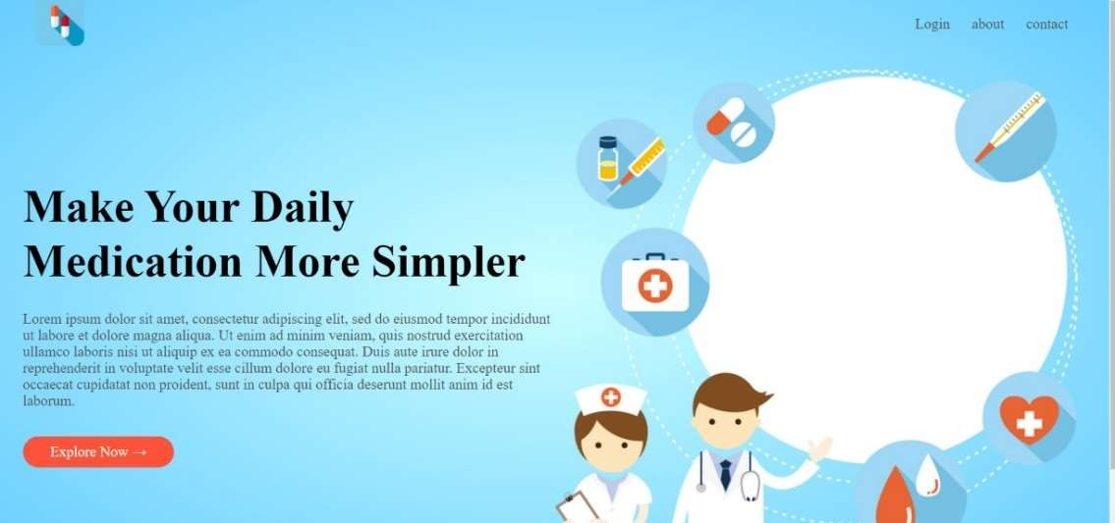providing that Screenshots of the output:

Fig no 5 : Home Page

This is the our welcome page for the I care web application.

It contains login , About and Contact Page .

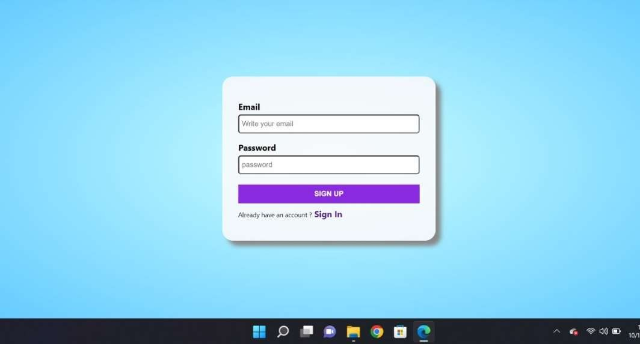

Fig no 6 : SignUp Page

This is the Sign Up Page for new users .

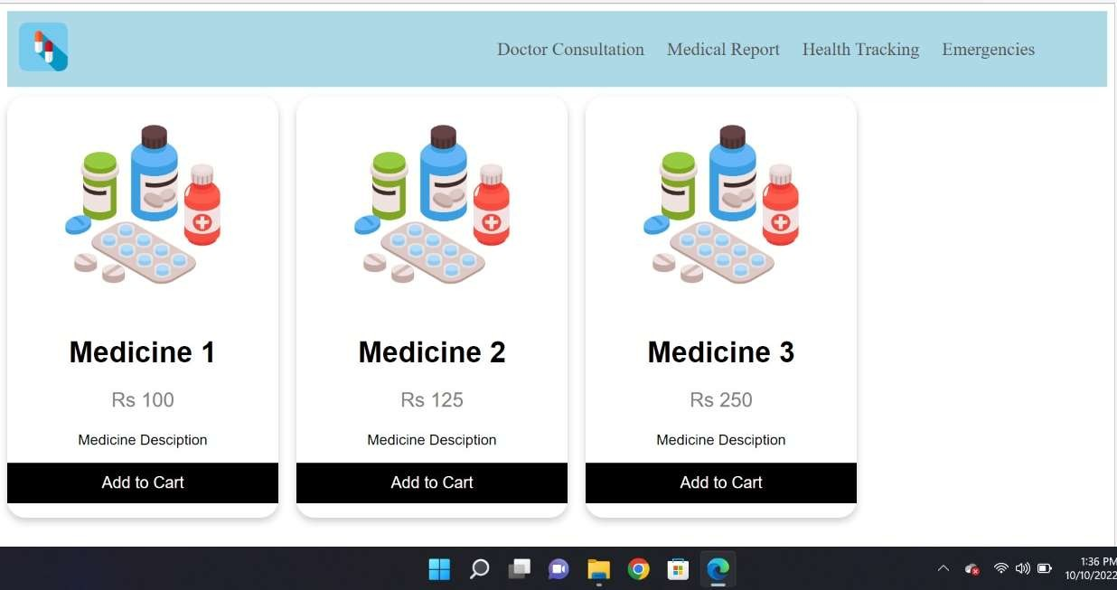

Fig no 7 : E-Pharmacy Page

This is the user view of the website ,to order medicine online with or without prescription.

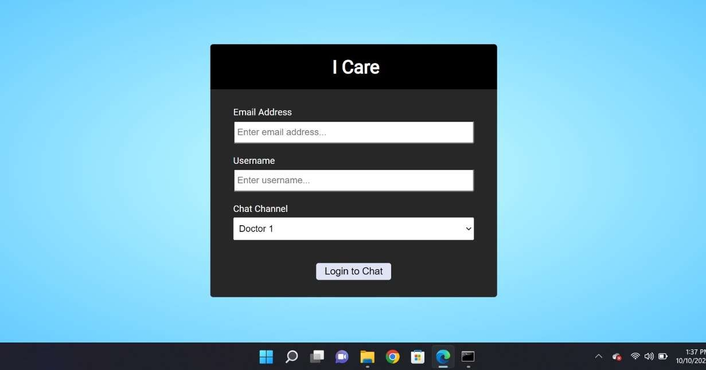

Fig no 8 : Dr Consultation login

The user will login through his credentials to communicate with the doctor .

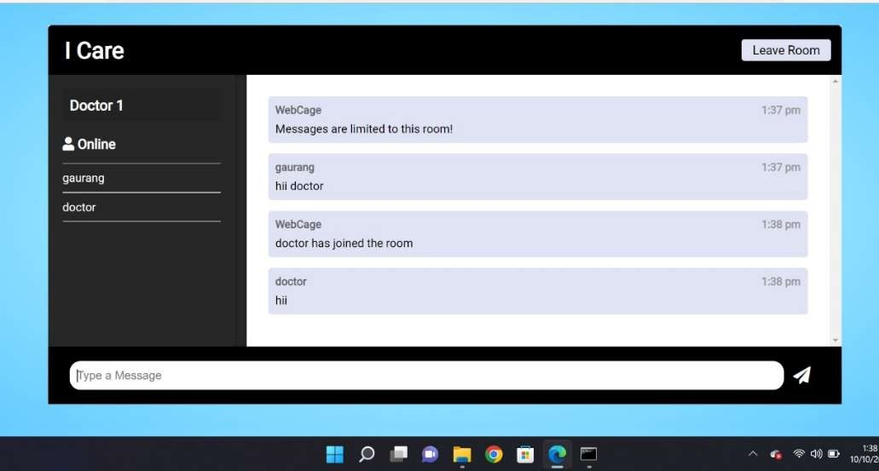

Fig no 9 : Dr Consultation

Here the user and doctor will communicate and the doctor will provide the necessary prescription.

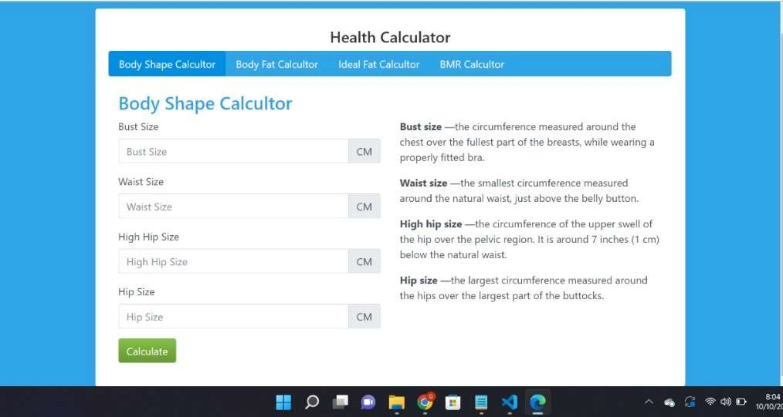

Fig no 10 : Health Tracker(Body Shape Calculator)

This module will calculate users body shape using the information provided by the user .

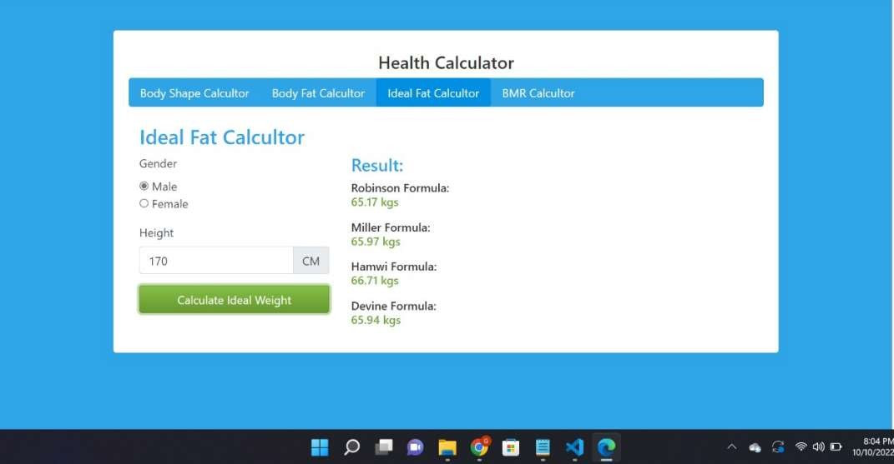

Fig no 11 : Health Tracker(Ideal Fat Calculator)

This module will calculate users body idea l fat using the information(height) provided by the user .

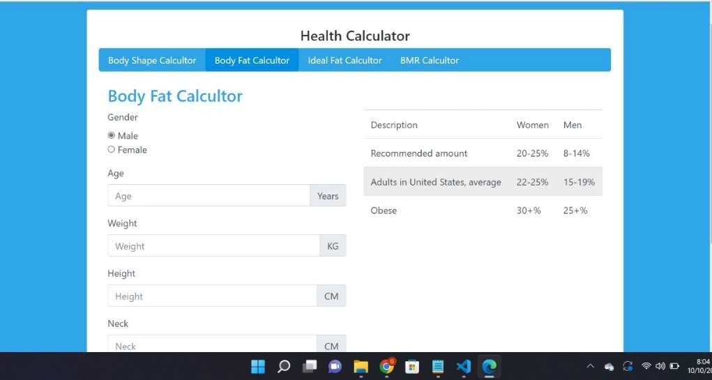

Fig no 12 : Health Tracker(Fat Calculator)

This module will calculate users body fat using the information provided by the user .

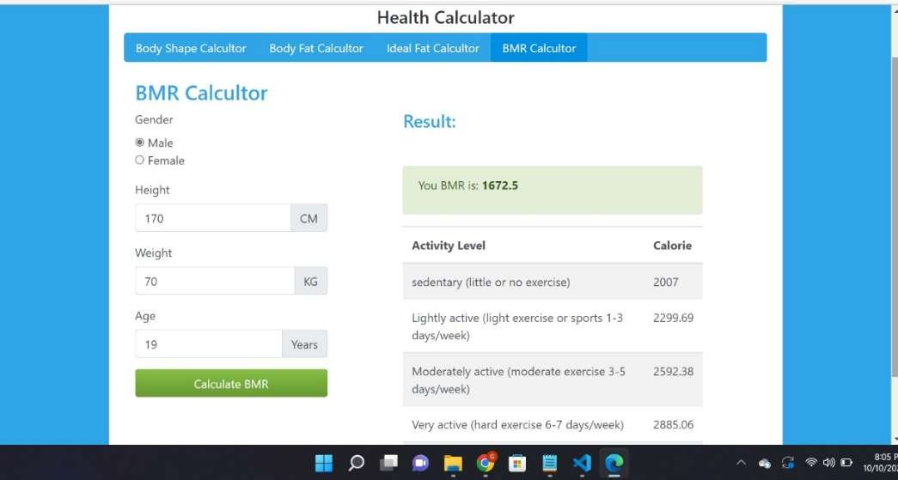

Fig no 13 : Health Tracker(BMR Calculator)

This module will calculate users BMR using the information provided by the user and recommend the obesity rate.

**Chapter 5**

**Conclusion**

So, this project is an integration of all health services in a single website for the ease of the customer. This business idea can bring a great change in medical field for ailments. Our system has no boundary of the user because everyone can use this system.

The use of Telehealth technologies has the potential to make a positive impact in the healthcare lives of patients. For example, it offers convenient health care on the patient’s time schedule therefore saving travel time for those in rural areas. In addition, it reduces healthcare costs for patients and improves the access to healthcare specialists. By using two-way video, mobile apps on smartphones, and other tools such as sensors and monitors, quality, life-saving routine, or preventative healthcare is provided.

**Chapter 6**

### Future Scope

Accuracy of monitoring devices and networks for communication Close and constant cooperation between patients and healthcare providers is key to chronic disease management. Comprehensive biometric information collected during the course of a patient's daily life needs to be reliably transferred to healthcare providers to enable ongoing monitoring of the patient's condition and prompt identification of a worsening prognostic condition that requires early intervention and secondary prevention.

The patient and doctor will have face to face virtual/video conversation which will increase the efficiency of the system so that the doctor could diagnose the patient more efficiently.

The health tracker might suggest symptoms or prescribe solution or medicine according to the data which the user will provide, and early detection of the disease according to the dataset.

There can be advancement in the health tracker by increasing various calculators.

In Medical report the user will be able to add his medical reports image and store in database for fast access of files anytime and anywhere.

There can be a module for notification of the medication and the appointments of doctor where the user will be notified according to the schedule the user provided. .

### References

* + Kreps GL, Neuhauser L. New directions in eHealth communication: Opportunities and challenges. Patient Educ Couns. 2019;78:329–36
  + E. Kyriacou, M.S. Pattichis, C.S. Pattichis et al., "m-Health e-Emergency Systems: Current Status and Future Directions", IEEE Antennas and Propagation Magazine, vol. 49, no. 1, pp. 216-231, 2021.
  + V. Ramani, T. Kumar, A. Bracken, M. Liyanage and M. Ylianttila, "Secure and Efficient Data Accessibility in Blockchain Based Healthcare Systems," 2020 IEEE Global Communications Conference (GLOBECOM), 2020, pp. 206-212, doi: 10.1109/GLOCOM.2018.8647221.
  + Berman, P (2020). ‘The Impoverishing effects of health Care payments in India: New methodology and findings’. Economic and Political weekly 27(16): 65-71.